**JOINS**

The JOIN clause in SQL is used to **combine rows from several tables based on a related column between these tables**.

There are several types of JOINs, each serving different purposes depending on how you want to retrieve and combine data from multiple tables.

4 Basic JOINS

1. INNER JOIN
2. LEFT JOIN
3. RIGHT JOIN
4. FULL /OUTER JOIN

**TASK**

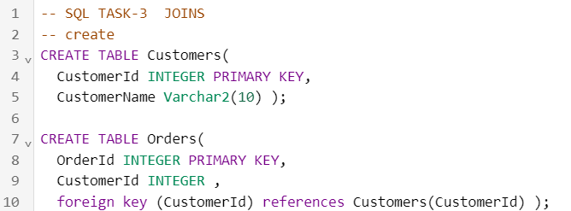

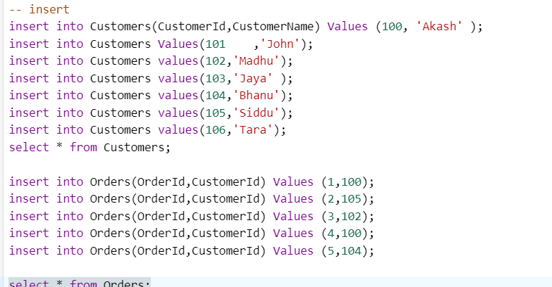

**Customers Table Orders Table**

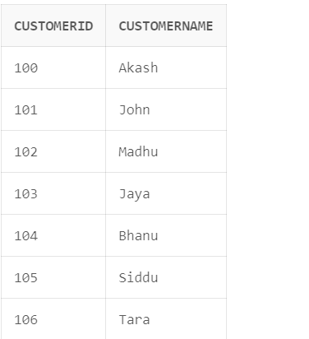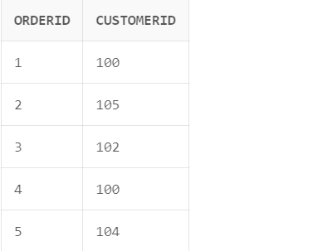

1. **INNER JOIN**

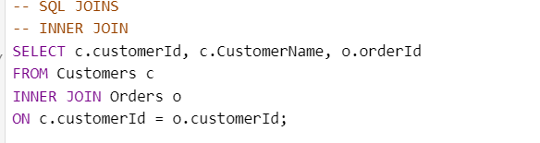

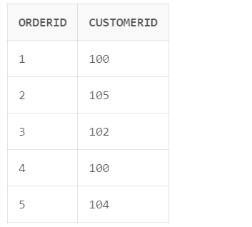

1. **LEFT JOIN**

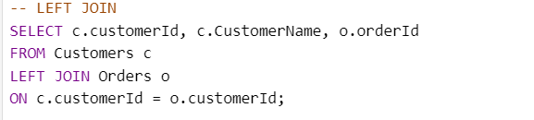

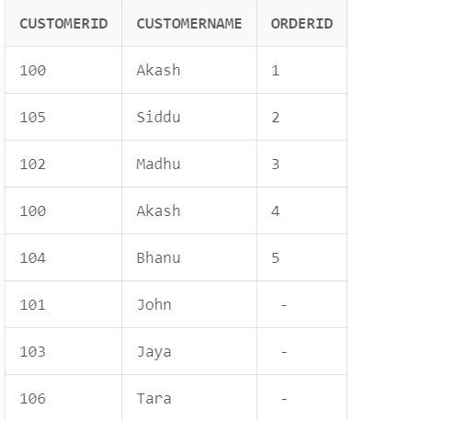

1. **RIGHT JOIN**

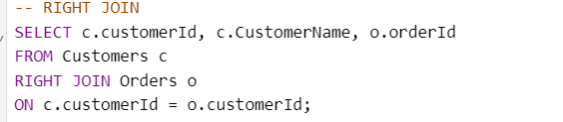

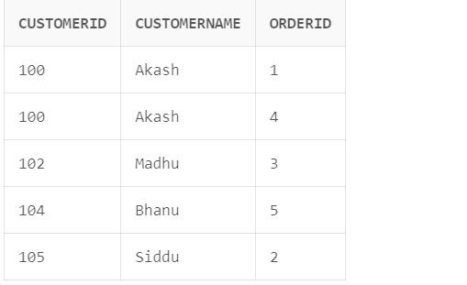

1. **FULL / OUTER JOIN**

